MEDS Lab — Module 1
Day 3 Report: Git Fundamentals & Version
Control

Name: Muhammad Kaleem Faryad
Course: MEDS Lab — Module 1
Day: 3
Topic: Git Fundamentals & Version Control

1. Git Data Model (Conceptual Understanding)
Git internally stores data as a Directed Acyclic Graph (DAG) of snapshots.

Components
- Blob: Stores raw file content (no filename or path).
- Tree: Represents a directory structure linking blobs and sub-trees.
- Commit: A snapshot of the project plus metadata (author, message, parent commit).
- Reference / Branch: A named pointer to a specific commit.
- HEAD: A special pointer indicating the current working branch.
■ Each commit points to its parent, forming a traceable history chain.

2. Initial Setup
Git global configuration was performed to identify the author of all commits:
git config --global user.name "Muhammad Kaleem Faryad" git config --global user.email "kaleemfaryad@gmail.com" git config --global init.defaultBranch main
Aliases were also configured for a faster daily workflow:
git config --global alias.st status git config --global alias.co checkout git config --global alias.br branch

Output

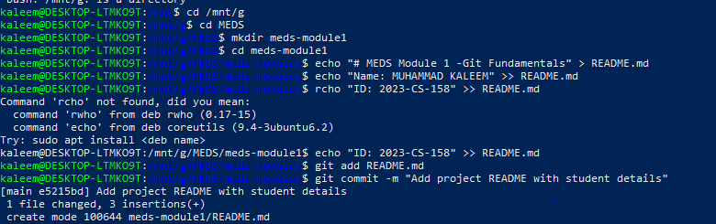

3. Core Git Workflow

Steps Followed
git init git add .
git commit -m "Initial commit"

Explanation
- Working Directory: Files currently being edited.
- Staging Area: Files prepared and marked for the next commit.
- Commit: A permanent snapshot of the staged project state.

Output
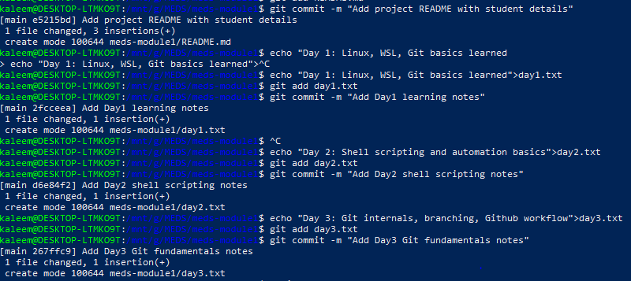

4. Exercise 1 — Repository Creation
A repository named meds-module1 was created containing the following files:
- README.md
- day1.txt, day2.txt, day3.txt
- src/alu.sv
Multiple meaningful commits were made to maintain a clear and readable project history.

Output

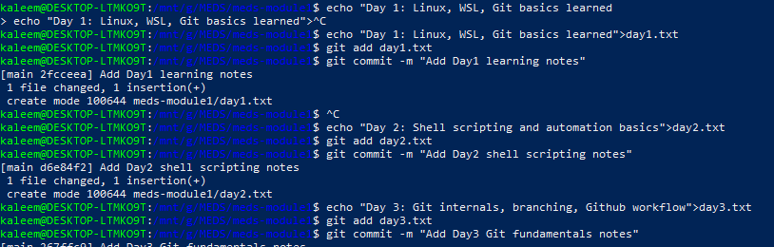

5. Commit Message Best Practices

Good Practices
- Use imperative tone (e.g., "Add multiplier module").
- Keep the summary line short — around 50 characters.
- Provide a detailed description body when extra context is needed.

Bad Examples
- "fixed stuff"
- "update"

6. Inspecting History

Commands Used
git log --oneline --graph --all git diff git diff --staged git show <commit>

Observations
- git log visualizes the full commit history as a graph.
- git diff shows unstaged file changes.
- git show displays the full details of a specific commit.

Output

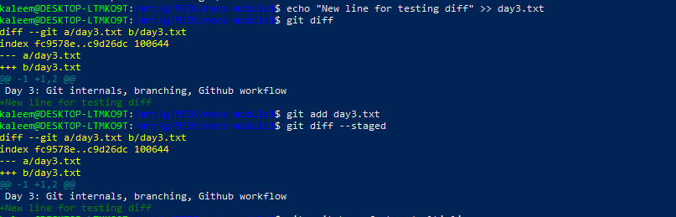

7. .gitignore Implementation
A .gitignore file was created to prevent unnecessary files from being tracked.

Ignored Files
- Simulation outputs (*.vcd, *.log).
- Build artifacts and compiled binaries.
- OS and editor-specific files (e.g., .DS_Store, .vscode/).

Exception
!important.log
■ This ensures important.log is tracked while all other .log files are ignored.

8. Branching and Divergence
Two feature branches were created to work on parallel development tasks:
git switch -c feature/multiplier git switch -c fix/overflow
Each branch modified the same file independently, demonstrating isolated development.

Visualization
git log --oneline --graph --all
■ This created branch divergence — multiple branches evolving from a common base commit.

Output

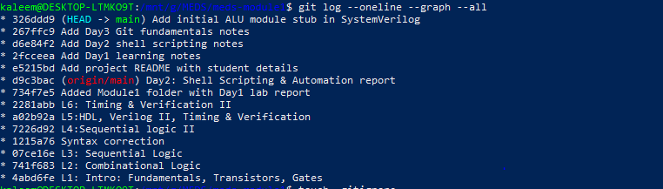

9. Merge and Conflict Resolution
Both branches were merged back into main: git merge feature/multiplier
git merge fix/overflow

Conflict in: src/alu.sv
Git inserted conflict markers to indicate the competing changes:
<<<<<<< HEAD =======
>>>>>>> branch-name

Resolution Steps
- Opened the conflicting file in a text editor.
- Manually reviewed and merged the two sets of changes.
- Removed all conflict markers.
- Staged the resolved file and created a final merge commit.

Output

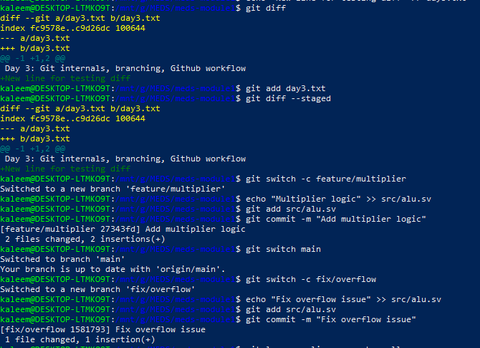

10. Git Diff and Undo Operations

Commands Practiced
git diff git diff --staged git restore --staged file git restore file

Understanding
- git diff compares the working directory against the staging area.
- git diff --staged compares the staging area against the last commit.
- git restore --staged unstages a file without losing changes.
- git restore discards all local changes to a file.

11. Git Blame (Exercise 6)
git blame src/alu.sv

Purpose
- Identify the author and timestamp of each individual line.
- Trace exactly which commit introduced a specific change.
Used in combination with: git show <commit>

Output

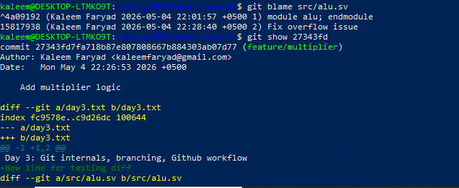

12. GitHub Integration

Steps Followed
- Created a new repository on GitHub.
- Added the remote origin using SSH.
- Pushed the local main branch to GitHub.
git remote add origin git@github.com:kaleemfaryad/meds-module1.git git push -u origin main

Issues & Solutions
Branch mismatch (main vs master) | Renamed local branch to main using git branch -m
Repository not found error | Created the repository on GitHub first, then pushed

Output

